Melissa Somers, Executive Director of the construction Crime Prevention Program of Southern California (CPP) introduced Austin Meechan-Maddon, CPP Executive Board member and sales representative for Coastline Equipment in Long Beach, who opened with words of gratitude for those in law enforcement working to combat the incredible amount of crime that occurs in the construction industry. He thanked all officers for their ongoing efforts and support of CPP, our members and the industry.
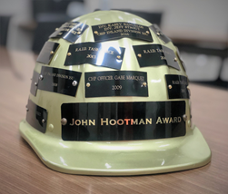
Melissa then shared the history of the John Hootman Memorial Award:
The John Hootman Memorial award is one of a kind; it is the only award presented in Southern California on behalf of the construction industry to individuals or agencies who serve the industry – law enforcement, task forces, insurance companies, and private investigators – who continue to raise awareness of and fight construction crime. It represents the gratitude CPP holds for our respected partners and honors the hard work, dedication and ingenuity required to investigate and recover heavy equipment.
The award is named after the late California Highway patrol investigator, John D Hootman of the Inland Division, honoring his memory as an officer who gave much time, effort, and enthusiasm to helping the construction industry prevent and resolve equipment crimes.
The John Hootman Memorial Award reflects upon the last major case Investigator Hootman spearheaded – nicknamed Hooter’s Hummer – a case involving an assortment of heavy equipment and attachments, an auction house and a PIN switching operation that rivaled something seen only on T.V. To this day, Investigator Hootman’s case remains one of the largest construction equipment recovery cases in the US – totaling $10 million dollars.
The award has two parts: a plaque for each winner and a hard hat engraved with all past winners that is passed along through the years.
Past recipients of the award were then asked to stand and be recognized.
TRAP North Team
RAID Task Force
Rob Oakleaf
John Nogues and John Rodriguez
Casey Banuelos and Jeff Strout
David Schwartzkopf
RAID Task Force
Karie Mendoza
Jim Kelley
Dale Nacarrow, Steve Kolb
CHP Border Division – ISU
CHP Coastal Division – SLOCATT
Michael Harris and Kurt Nester
Juan Ponce and Michael Hartmann
Richard Cheever and Lou Koven
Mike Perez
CHP Inland division
Gabe Marquez
JJ Rodrigues, Matt Lewis
Joe Williams, Ben Black and Rafael Virrueta

PRESENTATION OF THE 26TH ANNUAL JOHN HOOTMAN MEMORIAL AWARD
Melissa Somers, Executive Director, CPP SoCal

“Our partnerships with law enforcement throughout the region have made it possible for CPP to assist in the recovery of $1,482,805 in heavy equipment in 2021; and just over of $50 million since being founded in 1984. 2021 was yet another year filled with continual challenges yet the one thing that many of us knew we could always count on was you – our partners in law enforcement. I personally want to thank each and every one of you for your devotion, your service, and your unwavering support of CPP.
This year’s winner of the 26th Annual John Hootman Memorial Award is a team of two Deputies that make up the San Bernardino County Sheriff’s Dept’s Rural Crime Task force. The Rural Crime Unit is tasked with a variety of investigations ranging from animal cruelty to heavy equipment and metal theft. Their 2021 heavy equipment recoveries – totaling over $1.1 million - have helped individual owners, smaller businesses, many CPP members, and their entire community.
In addition to their remarkable recoveries, these Deputies have had an impressive impact in their community through their efforts in crime prevention, education, on-going investigations, and management of the area’s Owner Applied Number system. Their commitment to answering calls for assistance has continually impressed me - I am beyond grateful for their efforts and support.
It is my honor and pleasure to present the 26th annual John Hootman Memorial Award to Deputies Randy Stanley and John Francis.
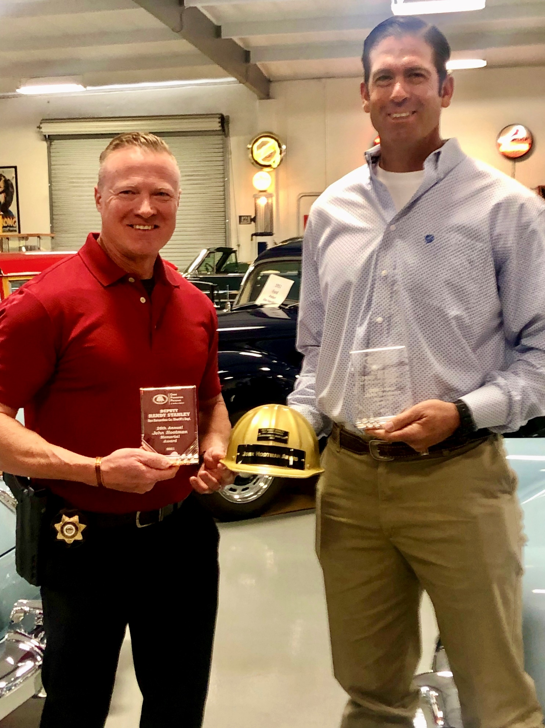
The construction industry Crime Prevention Program of Southern California (CPP) is a non-profit organization working with our members, law enforcement, the construction industry and area auto theft task forces to educate, empower and engage in a community fighting construction crime.
We believe, and strive to prove every day: "Together, We Make A Difference!"
For more information visit our website: www.cppsocal.org or call 562-860-9006.

